1.spring

IOC container(ConcurrentHashMap, store bean definition, instance)

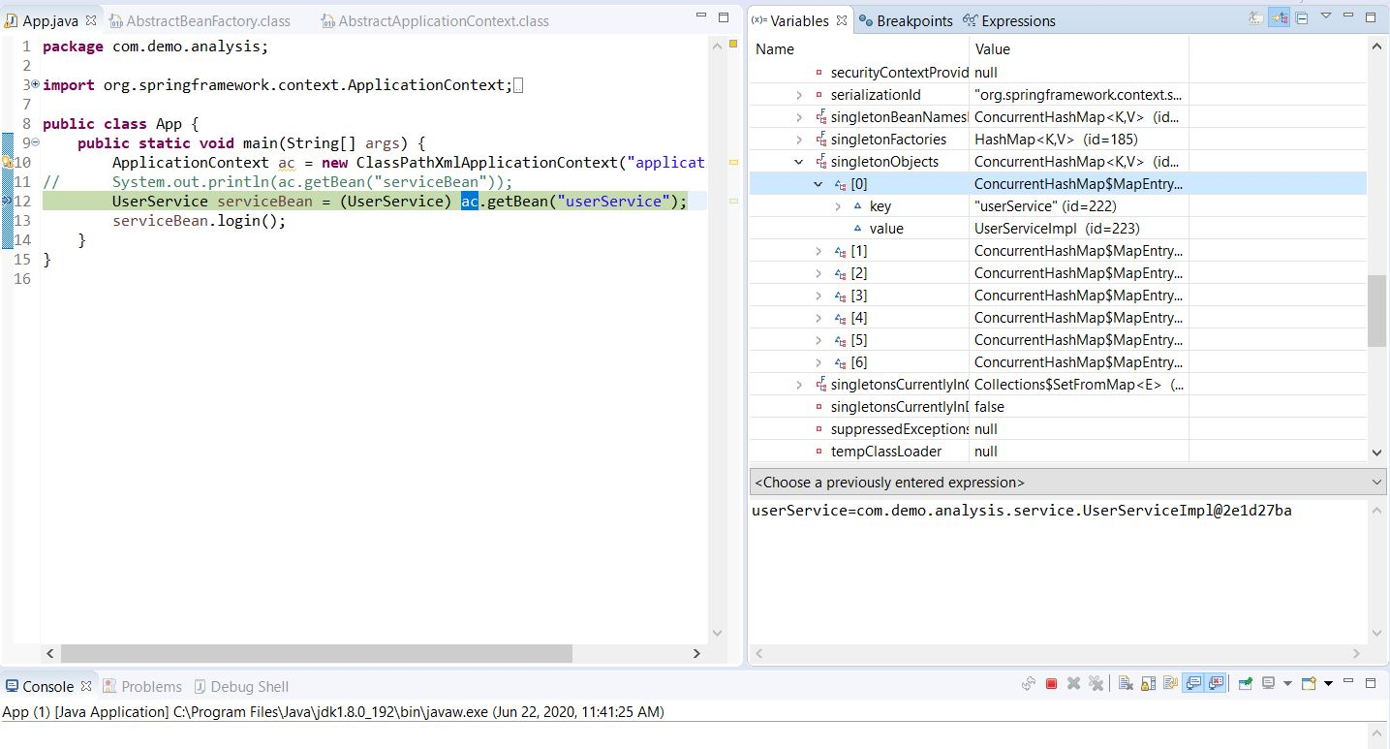

2.IOC/DI(Factory pattern, reflection) decouple

IOC: Reverse of controller

DI：Dependency injection

3.AOP(Dynamic proxy)

Aspect orientated programing: point cut, addition function

Transection

Update tableA request

Update tableB comment failed

Start

Try{

Object ret = invocation.proceed();

Commit }

Catch{

rollback

}

4. Flow

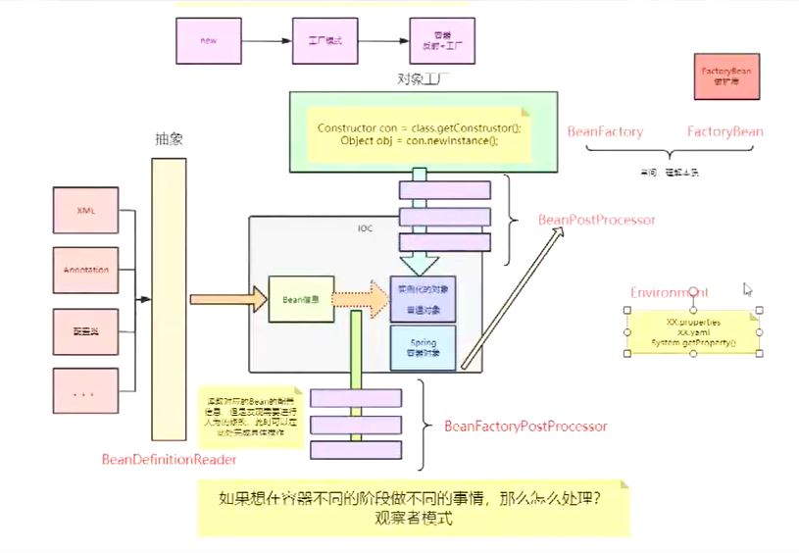

Spring(IOC container(DI,AOP))+springmvc(web)